Automatic Payment (ACH) Authorization

We offer a convenient system that automatically debits your payment from your checking or savings account each month. To take advantage of this FREE service, simply complete this form and return it to us with a voided check or preprinted deposit slip via email: Ldecamillo@ari-el.com

Tenant Name:

Tenant Business Address:

Address of Leased Premises (if different):

Contact Person:

Phone Number: ____________________________ Email: __________________________________________________________

Effective Date: ___________________________________ Lease Expiration Date: ___________________________________

I hereby authorize our landlord, its successors, assigns, and agent to initiate a debit from my checking/savings account listed below for my recurring scheduled monthly lease payment. If the required payment changes for any reason, this authorization will be automatically amended to authorize the debit of an amount equal to the new required payment.

Name on Account:

Bank Name:

Bank Address:

ABA Routing Number:

Account Number:

Account Type (please check one) Checking Savings

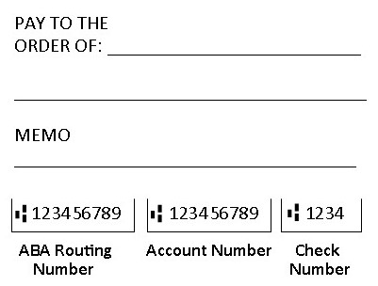

Important Note: Please continue making payments by check until you are notified that this authorization has
been processed and when the first transfer will occur.

The authorization to initiate a debit from my/our account will remain in full force and effect until the Lease expiration unless my/our landlord receives written notice from me/us of its termination at least 15 business days prior to the next scheduled draft date, or in such manner and time frame as to afford my/our landlord and its correspondent bank a reasonable opportunity to act upon it. Termination requests can be emailed using the return information in the first paragraph.

Account Holder

Signature: Date:

